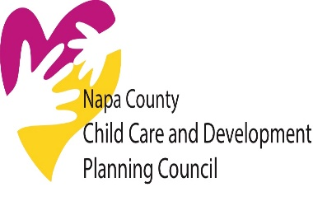
Napa County Child Care and Development Planning Council

MEETING AGENDA Napa Infant Program
September 1, 2021 1511-B Myrtle Avenue
Time: 9:00 a.m-11:00 a.m. Napa, CA 94558
https://meetings.ringcentral.com/j/1486859688
Time | Order of Business | Type
9:00 | 1. Organization- Emily Darlington, Presiding  - Call to Order & Introductions  - Approval of Minutes from June 2, 2021 meeting | Action
9:10 | 2. Public Comment: Members of the public may address the Planning Council on any subject within the Planning Council’s jurisdiction or request consideration to have an item placed on a future agenda. Individuals will be limited to a three-minute presentation. No action will be taken at this time by the Council as a result of any item presented. | Information
9:15 | 3. Council Roundtable and Announcements  - Parents Can-Marlena  - NVUSD- Audrey  - Napa County Board of Supervisors-Brad  - First 5 Napa-Emily  - Napa Bookmine- Elayna  - Child Start Inc.- Debbie  - Young World of Learning-Tina  - NVC/American Canyon Family Resource Center-Sherry  - City of St Helena-Amalia | Information/  Discussion/ Action
9:45 | 4. LPC Coordinators Report-Jeanne Fridolfs  - Early Care and Education 21/22 CA Budget Highlights  - Transition to DSS: link to website Child Care Transition  - WPG 21/22  - Napa County Redistricting Flyer  - Review of our areas of focus as determined at our May meeting for 21/22 | Information/  Discussion/ Action
10:05 | 5. LPC Chairpersons Report  - ARPA Funds Advocacy Efforts for Early Care and Education  - Quality Counts | Information/  Discussion/ Action
10:20 | 5. LPC Vacancies on Council | Discussion/Action
10:30 | 6. Website | Information/  Discussion/ Action
10:35 | 7. New Normal/Trends in Early Care and Education  - TK for all- how will it affect non-subsidized providers  - Child Care Provider Union | Information/  Discussion/ Action
10:45 | 8. COVID 19 Childcare response in Napa County  - COAD  - Childcare Challenges and Updates | Information/Discussion
11:00 | 9. Adjournment | Action
 | Next Meeting: October 6, 2021
Attachments: June 2, 2021 Meeting Minutes, State Budget Highlights, Napa Redistricting Flyer, CCPU Op Ed,
NOTE: Written materials relating to items on this agenda that have been distributed to the Napa County Child Care Planning Council 72 hours before the meeting are available for review by the public during normal business hours at the Napa County Office of Education, 1511-B Myrtle Ave, Napa. (SB 343)
If you are planning to attend and need special accommodations, please call Debbie Mays at (707) 253-6914 at least three days prior to the meeting.

